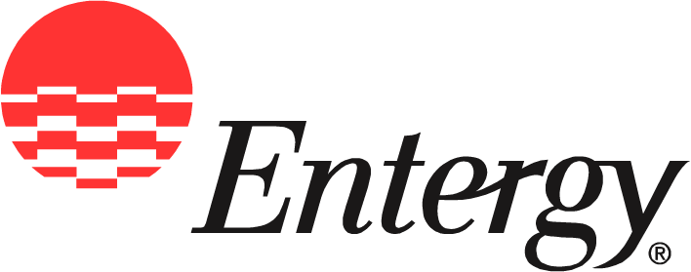
Entergy Nuclear
1340 Echelon Parkway
Jackson, MS 39213

News
Release

Date: | March 2, 2010

For Release: | Immediate

Contact: | Checky Herrington  601-368-5064 (office)  601-750-9030 (cell)  cherrin@entergy.com

Entergy Paves the Way for Careers in Nuclear Energy

Creative learning materials are designed to expand students’ opportunities.

Baton Rouge, La. – Entergy is fueling interest in nuclear science and power production through innovative learning materials provided to Louisiana schoolchildren.
Power Path to Nuclear Energy was shared with educators at the recent Louisiana Environmental Education Symposium in Baton Rouge and will be distributed statewide through other similar opportunities throughout the year.
“Part of Entergy’s commitment to customers is to help improve our communities,” said Renae Conley, president and CEO of Entergy Gulf States Louisiana, LLC. “By creating better educational opportunities for schoolchildren and expanding understanding of the importance of protecting our environment, Entergy is ensuring a better future for Louisiana.”
Nuclear energy is one of our nation’s most environmentally friendly sources of electricity. Entergy’s nuclear organization operates two nuclear power plants in Louisiana that provide electricity to Entergy Louisiana, LLC and Entergy Gulf States Louisiana, L.L.C. customers.
Because nuclear plants do not emit greenhouse gases in the conversion of fuel to electricity, the positive impact of just one of Louisiana’s nuclear power plants is equivalent to removing virtually all automobiles from the state’s roadways.
With the Power Path program, teachers provide entertaining lessons in nuclear science using workbook games and puzzles and online resources. Entergy’s support includes teacher training opportunities and enhancement of lesson plans through guest teaching and other employee volunteer opportunities. By creating an early interest in nuclear science, Entergy hopes to steer Louisiana students toward career choices related to nuclear power production.
“Our nation’s energy needs are growing every day, and so are environmental concerns,” said John Herron, president and CEO of Entergy Nuclear. “By providing the tools to help Louisiana’s young people understand nuclear power and production, we’re setting them on a path toward potential careers in a rapidly expanding industry.”
EnergySolutions Foundation, a national nonprofit organization dedicated to promoting math, science and engineering education, is providing the Power Path curriculum.
“The impact of a nuclear science curriculum for Louisiana students is many-faceted and far-reaching,” said Val Christensen, EnergySolutions president and CEO and a director of the foundation. “We’re pleased that Entergy has recognized the long-term benefits of introducing Louisiana’s schoolchildren to a fascinating field of learning.”
Entergy Corporation is an integrated energy company engaged primarily in electric power production and retail distribution operations. Entergy owns and operates power plants with approximately 30,000 megawatts of electric generating capacity, and it is the second-largest nuclear generator in the United States. Entergy delivers electricity to 2.7 million utility customers in Arkansas, Louisiana, Mississippi and Texas. Entergy has annual revenues of more than $10 billion and approximately 15,000 employees.

-30-

Entergy Nuclear’s online address is entergy-nuclear.com

Photo caption: Duane Merrell of EnergySolutions Foundation, a national organization, takes Louisiana science teachers through a classroom activity during Entergy’s Power Path to Nuclear Energy workshop at the recent Louisiana Environmental Education Symposium. Power Path provides entertaining lessons in nuclear science and is being provided to science teachers throughout the state through a partnership between the foundation and Entergy Louisiana L.L.C., Entergy Gulf States LLC, and Entergy Nuclear.

