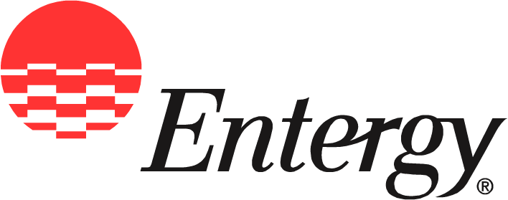
Entergy Nuclear
1340 Echelon Parkway
Jackson, MS 39213

News
Release

Date: | September 14, 2009

For Release: | Immediate

Contact: | Checky Hererington  601-368-5064 (office)  601-750-9030 (cell)  cherrin@entergy.com

Entergy Fueling Interest in Nuclear Energy Through Power Path Initiative

Creative teaching materials are being made available to students across the state.

Jackson, Miss. –Entergy continues to pave the way toward a bright future for Mississippi public school students through its Power Path to Nuclear Energy initiative announced last spring.
Company representatives have begun distributing curriculum materials as part of Entergy’s Destination Education initiative aimed at supporting Mississippi public education. The distribution is being coordinated with the Mississippi State Department of Education.
“By enhancing the educational experiences of Mississippi’s schoolchildren through compelling learning opportunities like Power Path, Entergy hopes to help reduce dropout rates and, at the same time, open doors to the future for Mississippi students,” said [CSM name], customer service manager for Entergy Mississippi, Inc.
Power Path supports the company’s commitment to seeking solutions to Mississippi’s—and the world’s—increasing energy needs. As demand for electricity grows, new generation sources are being explored. By preparing students now, Entergy is helping ensure a future workforce for a growing industry.
“Power Path to Nuclear Energy is an entertaining and exciting way to open Mississippi schoolchildren’s eyes and minds to the wonders and benefits of nuclear power,” said Mike Kansler, president and CEO of Entergy Nuclear. “We hope that teachers will embrace the curriculum and help students along the road toward rewarding careers in nuclear power production.”
Entergy Nuclear, the nation’s second-largest producer of nuclear power, is headquartered in Jackson. Mississippi’s Grand Gulf Nuclear Station near Port Gibson is one of 11 nuclear reactors owned and operated by Entergy.
EnergySolutions Foundation, a nonprofit national organization dedicated to promoting math, science and engineering education, is providing the Power Path curriculum. Mississippi is the first state to adopt the materials.
"Increasing public understanding of nuclear energy and stimulating the interest of young people in science and engineering are two goals that are vital to the future of our industry," said Steve Creamer, EnergySolutions chairman and CEO, and a director of the EnergySolutions Foundation. "We’re pleased that Entergy and the Mississippi Department of Education have recognized the long-term benefits of Power Path to Nuclear Energy.”
Public school science teachers grade 7-12 can easily incorporate Power Path’s games, puzzles and online resources into classroom activities.
"Entergy Nuclear's Power Path curriculum will provide our students the knowledge to get them interested and excited about a career in nuclear science," Interim Mississippi State Superintendent of Education Dr. John W. Jordan said.

To ensure the program’s success, Entergy will provide ongoing support to Power Path through teacher training, guest teaching, and other employee volunteer opportunities.
Power Path reflects a unique partnership between Entergy, the Mississippi State Department of Education, and EnergySolutions. The partnership supports the state’s On the Bus initiative, which encourages private entities to get on board in improving public education.
“By working together, we can help make a difference for Mississippi’s schoolchildren,” said [CSM name.] “At the same time, through Power Path to Nuclear Energy, we are supporting Mississippi’s economic growth by fostering a future workforce, which benefits us all.”
Entergy Corporation is an integrated energy company engaged primarily in electric power production and retail distribution operations. Entergy owns and operates power plants with approximately 30,000 megawatts of electric generating capacity, and it is the second-largest nuclear generator in the United States. Entergy delivers electricity to 2.7 million utility customers in Arkansas, Louisiana, Mississippi and Texas. Entergy has annual revenues of more than $13 billion and approximately 14,700 employees.

-30-

Entergy [Company]’s online address is entergy-[company].com

