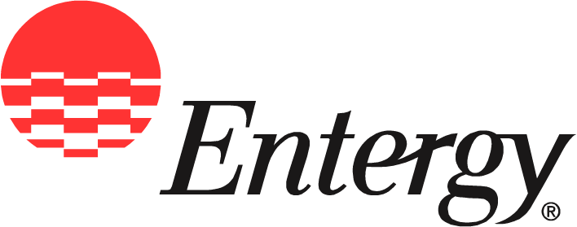
Entergy
308 E. Pearl St.
Jackson, MS 39215

News
Release
Date: | April 20, 2007

For Release: | IMMEDIATE

Contact: | Checky Herrington  (601) 969-2329 office  (601) 750-9030  cherrin@entergy.com

Generation E Meets Environmental Challenges of Today and Tomorrow
Entergy’s new initiative promotes utility’s many forward-thinking programs

Jackson, Miss. – In recognition of Earth Day 2007, Entergy Mississippi has renewed its forward-thinking environmental focus through a new initiative called Generation E.
Aimed at preserving the environment, the plan takes an aggressive approach to reducing greenhouse gas emissions, exploring new nuclear opportunities, launching educational programs, and encouraging others to make similar commitments.
“Generations are generally defined by specific time periods or cultures,” said Carolyn Shanks, president of Entergy Mississippi. “In recent years, certain age groups sharing specific cultural characteristics have been known as Generation X or Generation Y.
“But Generation E encompasses all ages, all races, all levels of society,” she said. “One thing every person on the planet shares is the need to protect our earth.
“Air pollution, coastal erosion, and other contributors to climate change affect us all,” she said. “There are no gaps in Generation E. Finding solutions is everyone’s responsibility.”
Shanks noted that Entergy has already established itself as an environmental champion by being the nation’s first utility to voluntarily reduce greenhouse gas emissions from its generating plants. The company recently renewed this commitment, aiming for further reductions over the next five years.
In addition, legislative efforts on the part of the company are encouraging sweeping policy changes on emissions.
Such steps have earned Entergy a spot on the Dow Jones Sustainability Index five years in a row. Last year, Entergy was the only U.S. utility named in the report.
To further efforts to improve the environment, Entergy will expand partnerships with national organizations with similar intent such as Keep America Beautiful, Energy Star and the Nature Conservancy. Entergy employees will participate in litter pickups, educational presentations, and other successful programs.
A major emphasis will be consideration of new nuclear generation at the company’s current Grand Gulf Nuclear Site. In addition, Entergy will be exploring the benefits of offering to customers electricity produced by other green power sources such as wind and ethanol as well as creating better ways for customers to monitor and control their own energy use.
Through Generation E, the company’s commitments at the local level will be expanded. Entergy Mississippi made history by building the state’s first Energy Star certified Habitat for Humanity home. Design elements which support weatherization and other energy-saving objectives will be used in future builds.
The seeds of community environmental ideas like nature area improvements will grow and flourish through Entergy Mississippi’s environmental stewardship grant program. One recent grant allowed the National Wild Turkey Federation to improve Entergy right-of-way acreage in the Natchez area into an excellent brood-rearing environment for wild turkeys.
Entergy’s reforestation program will help maintain Mississippi’s abundant natural resources while reducing carbon dioxide in the atmosphere. Through Entergy’s efforts, black bear and other endangered species will find more viable habitats.
Additional efforts to remove carbon dioxide from Mississippi’s atmosphere include a program which directly deposits carbon emissions back into dormant oil wells to recover oil deposits currently untapped by conventional extraction techniques. Entergy partners with Blue Source, L.L.C. and Denbury Resources to leverage this approach in southwest Mississippi oilfields.
Shanks emphasizes that now, more than ever, business leaders, law makers, community activists, and all citizens must come together to address growing environmental challenges. Entergy encourages customers to do their part through its Simple Steps energy awareness program offering simple lifestyle suggestions which can add up to big energy savings.
“Preserving the environment is the defining issue of our time,” said Shanks. “Entergy intends to lead the way to a bright future for other generations through Generation E.”
Entergy Mississippi provides electricity to more than 427,000 customers in 45 counties. It is a subsidiary of Entergy Corporation. Entergy Corporation is an integrated energy company engaged primarily in electric power production and retail distribution operations. Entergy owns and operates power plants with approximately 30,000 megawatts of electric generating capacity, and it is the second-largest nuclear generator in the United States. Entergy delivers electricity to 2.7 million utility customers in Arkansas, Louisiana, Mississippi and Texas.

-30-
Entergy Mississippi’s on-line address is www.entergy-mississippi.com

