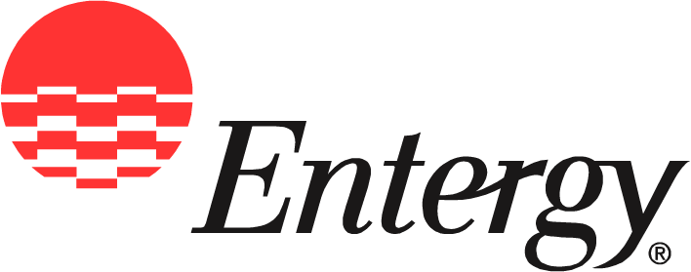
Entergy Operations, Inc.
Bald Head Road
Port Gibson, MS 39150

News
Release

Date: | July 1, 2010

For Release: | Immediately

Contact: | Checky Herrington  601-750-9030  cherrin@entergy.com

Grand Gulf Nuclear Station Celebrates 25 Years of Powering Mississippi

Plant continues longstanding record of safe, reliable and virtually emission-free generation

Port Gibson, Miss. – In 1985, Ronald Reagan took the oath of office for his second term and “New Coke” was introduced and quickly rejected by consumers. On July 1 of that same year, Entergy also made history with the opening of Grand Gulf Nuclear Station, marking a new era of safe, reliable, affordable and virtually emission-free electricity production for the people of Mississippi.
“Power from Grand Gulf plays a crucial role in filling Mississippi’s energy needs, and of course, the energy we generate domestically lessens our dependence on foreign energy sources,” said Mississippi Governor Haley Barbour. “As a major industrial site, Grand Gulf also serves as an economic driver for the state contributing significant tax dollars, stabilizing utility costs and helping attract other industries.”
Grand Gulf provides approximately 700 jobs in the community, has a payroll of about $70 million and pays $29 million in taxes each year. The plant is known worldwide for its commitment to safe operations, industry-leading performance records and a legacy of community leadership.
“For 25 years, the employees of Grand Gulf have carried through on a promise to operate the plant in a safe and responsible manner,” said Randy Douet, vice president of operations at Grand Gulf. “We greatly value the trust of the public and our place in the community.”
Benefits of Grand Gulf also include saving Entergy Mississippi, Inc.’s 435,000 customers hundreds of thousands of dollars a day compared to electricity produced using other fuels like natural gas.
“Having Grand Gulf as part of the energy mix in Mississippi has had an overwhelmingly positive impact for the economy and the environment,” said Haley Fisackerly, president and chief executive officer of Entergy Mississippi, Inc. “Over the years, Grand Gulf has helped keep customer rates stable and acted as a buffer against the unpredictable prices of natural gas.
“In addition, Grand Gulf’s clean-air generation helps protect Mississippi’s valuable natural resources.”
Grand Gulf is also committed to improving the community. Plant workers regularly combine forces with Entergy Mississippi employees to help with fund-raising and volunteer efforts in Port Gibson and Claiborne County.
“Our employees feel a deep connection to the community, as well as an obligation to help improve the quality of life where they live and work,” Fisackerly said. “That’s a trademark of Entergy employees wherever you go, and Grand Gulf is a prime example of that spirit of generosity.”
Plans for an upgrade that will increase the plant’s production capacity will be completed by 2012 and make Grand Gulf Nuclear Station the largest single-unit nuclear power producer of its type in the world.
“Support from the state and community paired with Entergy’s high standards of excellence have kept Grand Gulf operating safely and successfully for 25 years,” Douet said. “Those are the same qualities that will continue fueling Grand Gulf well into the future.”
Entergy Corporation is an integrated energy company engaged primarily in electric power production and retail distribution operations. Entergy owns and operates power plants with approximately 30,000 megawatts of electric generating capacity, and it is the second-largest nuclear generator in the United States. Entergy delivers electricity to 2.7 million utility customers in Arkansas, Louisiana, Mississippi and Texas. Entergy has annual revenues of more than $10 billion and more than 15,000 employees.

Learn more about Grand Gulf Nuclear Station
through a series of videos at entergy-nuclear.com.

Follow Entergy Nuclear on Twitter, @EntergyNuclear

-30-

