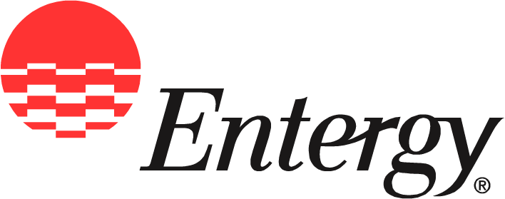
Entergy Operations, Inc. Arkansas Nuclear One
1448 S.R. 333
Russellville, AR 72802

News
Release

Date: | Dec. 3, 2009

For Release: | Immediately

Contact: | Checky Herrington  601-368-5064 (office)  cherrin@entergy.com

Arkansas Nuclear One: Celebrating 35 Years of Powering Arkansas

Plant continues longstanding record of safe, reliable and emission-free generation

Russellville, Ark. – Beginning in December, Arkansas Nuclear One launches a year-long celebration commemorating 35 years of powering Arkansas, starting with an employee picnic and a presentation to state and local leaders on ANO’s accomplishments and commitment to meet the energy needs of the future.
The plant, touted at its announcement as “the greatest thing in the Valley,” began commercial operation on Dec. 19, 1974, marking a new era of safe, reliable and emission-free electricity production for the people of Arkansas. Today, the station is known worldwide for its commitment to safe operations, industry-leading performance records and a legacy of community leadership and involvement.
“ANO’s reputation as one of the nuclear industry’s top-performing plants is a success story not only for Entergy, but also for the people of Arkansas,” said Kevin Walsh, vice president of operations at ANO. “For more than three decades, the employees of ANO have carried through on a promise to operate the plant in a safe and responsible manner, greatly valuing the trust of the public and our place in the community.”
Safety is an overriding priority in nuclear energy and a realm of performance in which ANO employees have excelled. In 1996, ANO became the first nuclear plant in the nation to be admitted into the Occupational Safety and Health Administration’s Voluntary Protection Program. ANO was inducted at the Star level, the highest recognition in industry safety, and has remained there ever since.
ANO’s second unit went into commercial operation in 1980. Now, ANO’s two units generate more than 50 percent of the electricity used by Entergy Arkansas’ 684,000 customers and account for a quarter of the electricity used throughout all of Arkansas.
In addition, ANO provides approximately 1,000 jobs in the community and makes significant contributions to the tax base of Russellville and Pope County.
“Having ANO as part of the energy mix in Arkansas has had an overwhelmingly positive impact for the economy and the environment,” said Hugh McDonald, president and chief executive officer of Entergy Arkansas, Inc. “Over the years ANO has helped keep customer rates stable and acted as a buffer against the unpredictable prices of natural gas. Nuclear plants also produce large amounts of electricity without adding carbon to the atmosphere.”
ANO and its employees regularly combine forces to help with numerous fundraising and volunteer efforts in Russellville and surrounding communities. On average, ANO employee contributions plus matching funds from Entergy account for about 40 percent of the River Valley United Way’s annual fund drive contributions. In addition to United Way matching funds, this year Entergy shareholders will contribute more than $100,000 to worthy causes in the Arkansas River Valley area.
“ANO employees feel a deep connection to the community, as well as an obligation to help improve the quality of life where they live and work,” Walsh said. “That’s a trademark of Entergy employees wherever you go, and ANO is a prime example of that spirit of generosity.
“We also recognize our obligation to the people of Arkansas to operate the plant in a safe and responsible manner,” he said. “Our respect for nuclear technology and our high standards of excellence have kept ANO operating safely and successfully for 35 years, and those are the same qualities that will continue fueling ANO well into the future.”
Entergy Corporation is an integrated energy company engaged primarily in electric power production and retail distribution operations. Entergy owns and operates power plants with approximately 30,000 megawatts of electric generating capacity, and it is the second-largest nuclear generator in the United States. Entergy delivers electricity to 2.7 million utility customers in Arkansas, Louisiana, Mississippi and Texas. Entergy has annual revenues of more than $13 billion and approximately 14,700 employees.

Entergy Operations, Inc.’s online address is entergy-nuclear.com.

-30-

