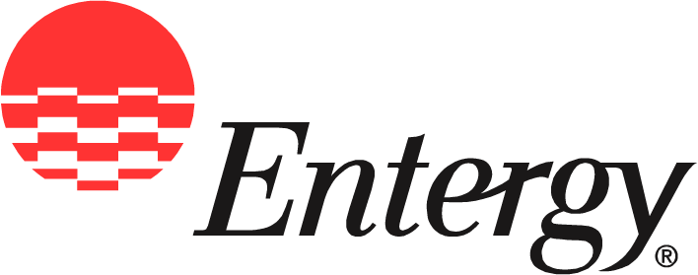
Entergy Operations, Inc.
Plant Name
Street Address
City, State Zip Code

News
Release

Date: | Month, Day, Year

For Release: | Month, Day, Year

Contact: | Insert name here (Use Shift-Enter between lines)  (xxx) xxx-xxxx office  (xxx) xxx-xxxx pager (or home)  e-mail address

[Site] Celebrates National Nuclear Science Week with Powerful Presentation

Nuclear [job description ie; engineer, control room operator] shares the benefits of nuclear power with local students.

[City, state] — [Name, title] helped [Site] celebrate National Nuclear Science Week by sharing with [school name] students the benefits of the clean, affordable energy [he/she] works to help produce every day.

National Nuclear Science Week is a new broadly observed week-long celebration January 25-29 intended to advance public and industry awareness of nuclear’s key benefits and to recognize the professionals who lead and manage nuclear organizations. Celebrations highlight how human knowledge has directed the energy of our most fundamental component, the atom, to the service and progress of our communities and world.
“Producing electricity using nuclear power is one of our nation’s most valuable resources,” said [Name, title]. “At [site], we’re proud of the part we play in keeping electricity rates low and preserving our environment.”
Nuclear power production uses small amounts of domestic fuel and is virtually emission free. [Site] is one of 11 nuclear power plants owned and operated by Entergy Nuclear. The plants are situated throughout the Southeast, Northeast, and in Michigan. In addition, Entergy Nuclear manages operations for a 12th plant situated in Nebraska.
During the presentation, [name] explained plant operations and Entergy [operating company] customers benefit from lower costs.
“Our students were fascinated to learn how electricity is made at a nuclear plant,” said [school representative name, title]. “To know more about the way our community helps provide clean power to so many people was very exciting.”
[Site] produces [number] Megawatts of electricity, enough to power [number] homes. In addition, the plant avoids [number] of greenhouse gas emissions annually compared to producing electricity using other fuels like natural gas and coal.
“With public interest in the nuclear industry growing, National Nuclear Science Week provides us another opportunity to tell our story,” said [Name]. “Through these presentations, we are helping increase public understanding of our industry and how nuclear energy helps power our world.”
National Nuclear Science Week is initiated by the National Museum for Nuclear Science and History located in Albuquerque, N.M., and national and professional organizations in the fields of medicine, energy, research and education. For additional information visit NuclearScienceWeek.com
Entergy Corporation is an integrated energy company engaged primarily in electric power production and retail distribution operations. Entergy owns and operates power plants with approximately 30,000 megawatts of electric generating capacity, and it is the second-largest nuclear generator in the United States. Entergy delivers electricity to 2.7 million utility customers in Arkansas, Louisiana, Mississippi and Texas. Entergy has annual revenues of more than $13 billion and approximately 14,700 employees.
-30-
Entergy Nuclear’s address is entergy-nuclear.com.

